**7PAM2000 Applied Data Science 1  
Assignment 2: Statistics and trends**

TIN CU KANG (SRN: 22044379)

School of Physics, Engineering and Computer Science, University of Hertfordshire

13 December 2023

<https://github.com/cukang98/ADS1-Assignment1-Visualization>

Data source: <https://beta.data.gov.sg/collections/189/view>

**Abstract**

This report explores the trends and relationships among key indicators, focusing on urban population growth, electricity production, agriculture value added (% of GDP), CO2 emissions, forest area, and GDP annual growth for selected countries. The data, sourced from the World Bank, spans the years 2000 to 2015. The analysis involves data cleaning, descriptive statistics, and correlation assessments. The study utilizes visualizations, including line plots and grouped bar charts, to present the temporal evolution of selected indicators across countries. Additionally, correlation heatmaps are employed to unveil the interplay between different variables. The report concludes with statistical insights, shedding light on skewness, kurtosis, average, and standard deviation for urban population growth, electricity production, agriculture value added, CO2 emissions, forest area, and GDP annual growth. The findings provide a comprehensive understanding of the dynamics and relationships within the chosen indicators, contributing valuable insights for further research and policy considerations.

**Contribution of Agriculture, Forestry, and Fishing to GDP**

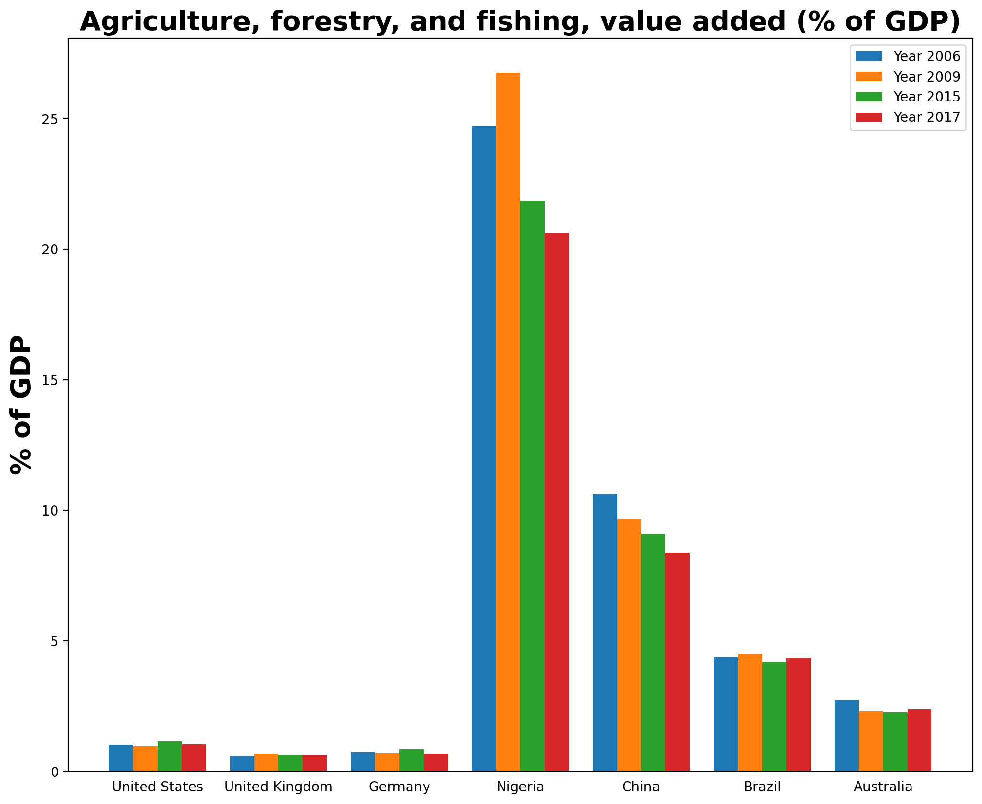

bar plot showcases the GDP impact of these industries in Germany, the USA, the UK, Nigeria, China, Brazil, and Australia over four years (1997, 2003, 2009, and 2015). Notably, the plot emphasizes that these sectors play a pivotal role in contributing the highest share to Nigeria's GDP compared to the other featured countries.

**Annual Urban Population Growth Across Nations**

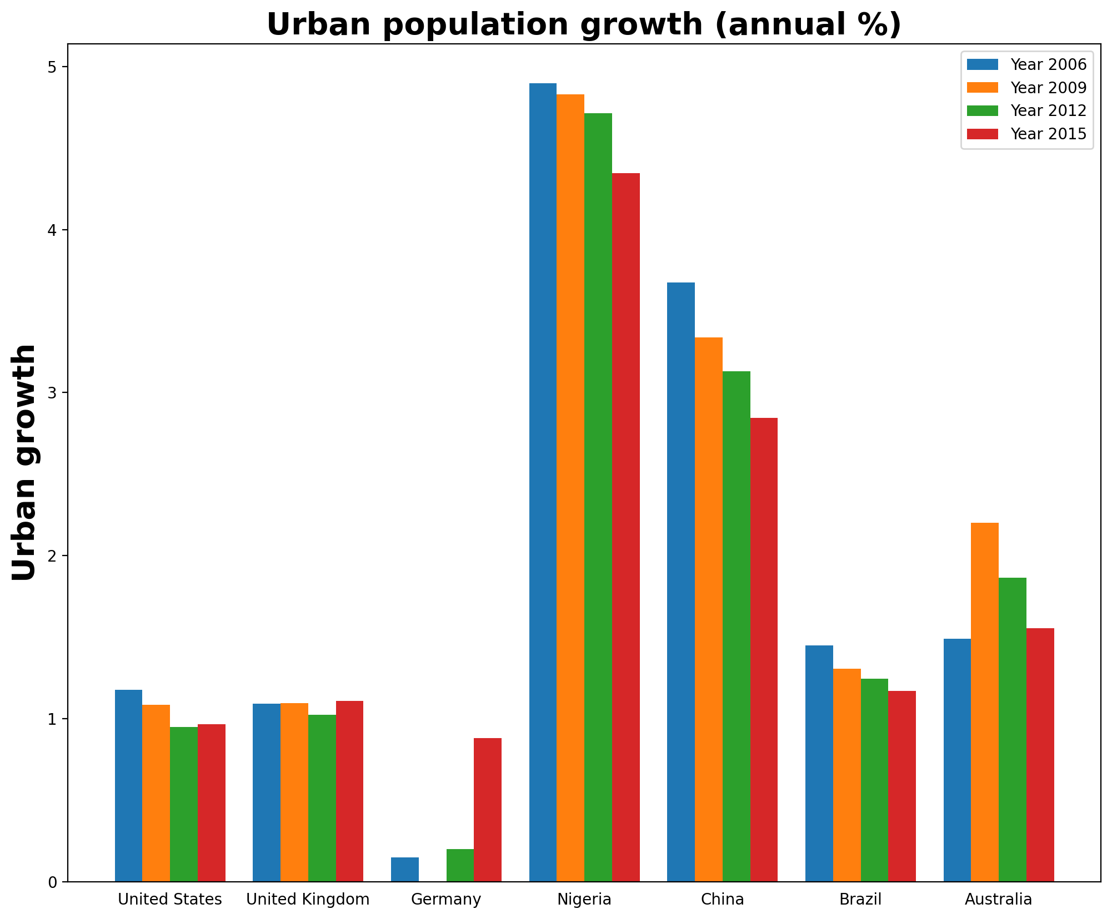

bar plot illustrates the yearly urban population growth for Germany, the USA, the UK, Nigeria, China, Brazil, and Australia spanning four years (1997, 2003, 2009, and 2015). Notably, Germany, the UK, and Australia experienced an upward trend in growth, while Nigeria and China observed a decline. The plot highlights specific years with notable growth rates: 2015 for Germany, 1997 for the USA, 2015 for the UK, 2003 for Nigeria, 2003 for China, 1997 for Brazil, and 2009 for Australia.

**Trends in Electricity Production Sources Across Nations**

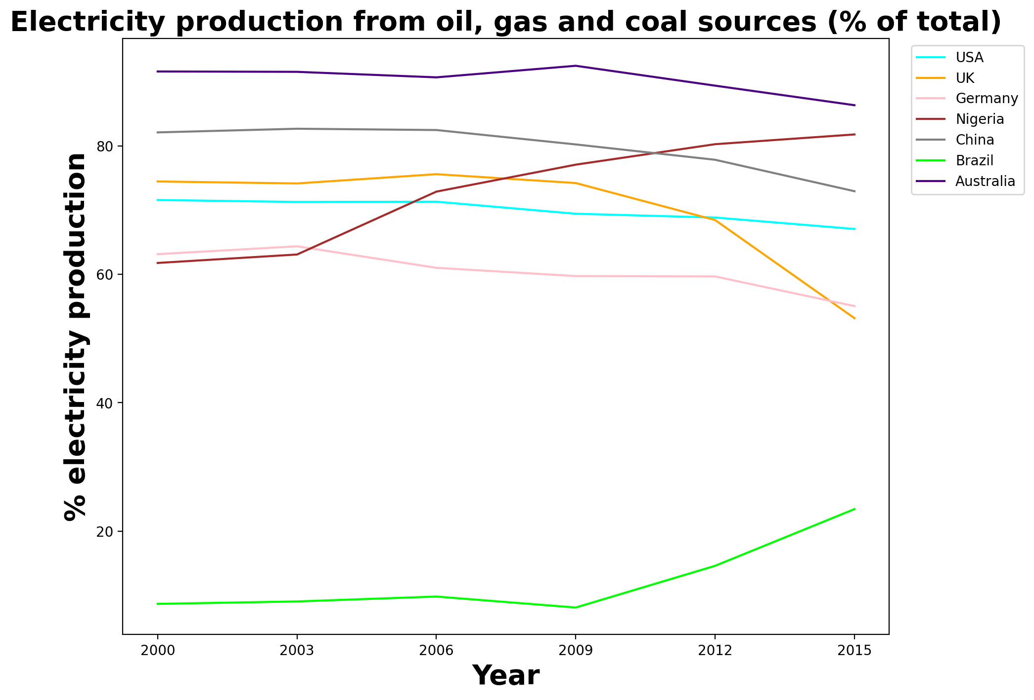

Chart above depicting the percentage of electricity production from oil, gas, and coal sources for the USA, UK, Germany, Nigeria, China, Brazil, and Australia between 2000 and 2015 reveals distinctive patterns. Nigeria experienced a significant increase in reliance on these sources from 2003 onwards, while Brazil, starting from a lower point, displayed a gradual upward trend since 2009. Conversely, the UK showcased a decreasing trend, indicating a shift towards cleaner energy sources. The USA, Germany, China, and Australia did not exhibit consistent patterns over the specified years, showcasing variability in their energy mix during this period.

**Per Capita CO2 Emissions: A Comparative Analysis Across Nations**

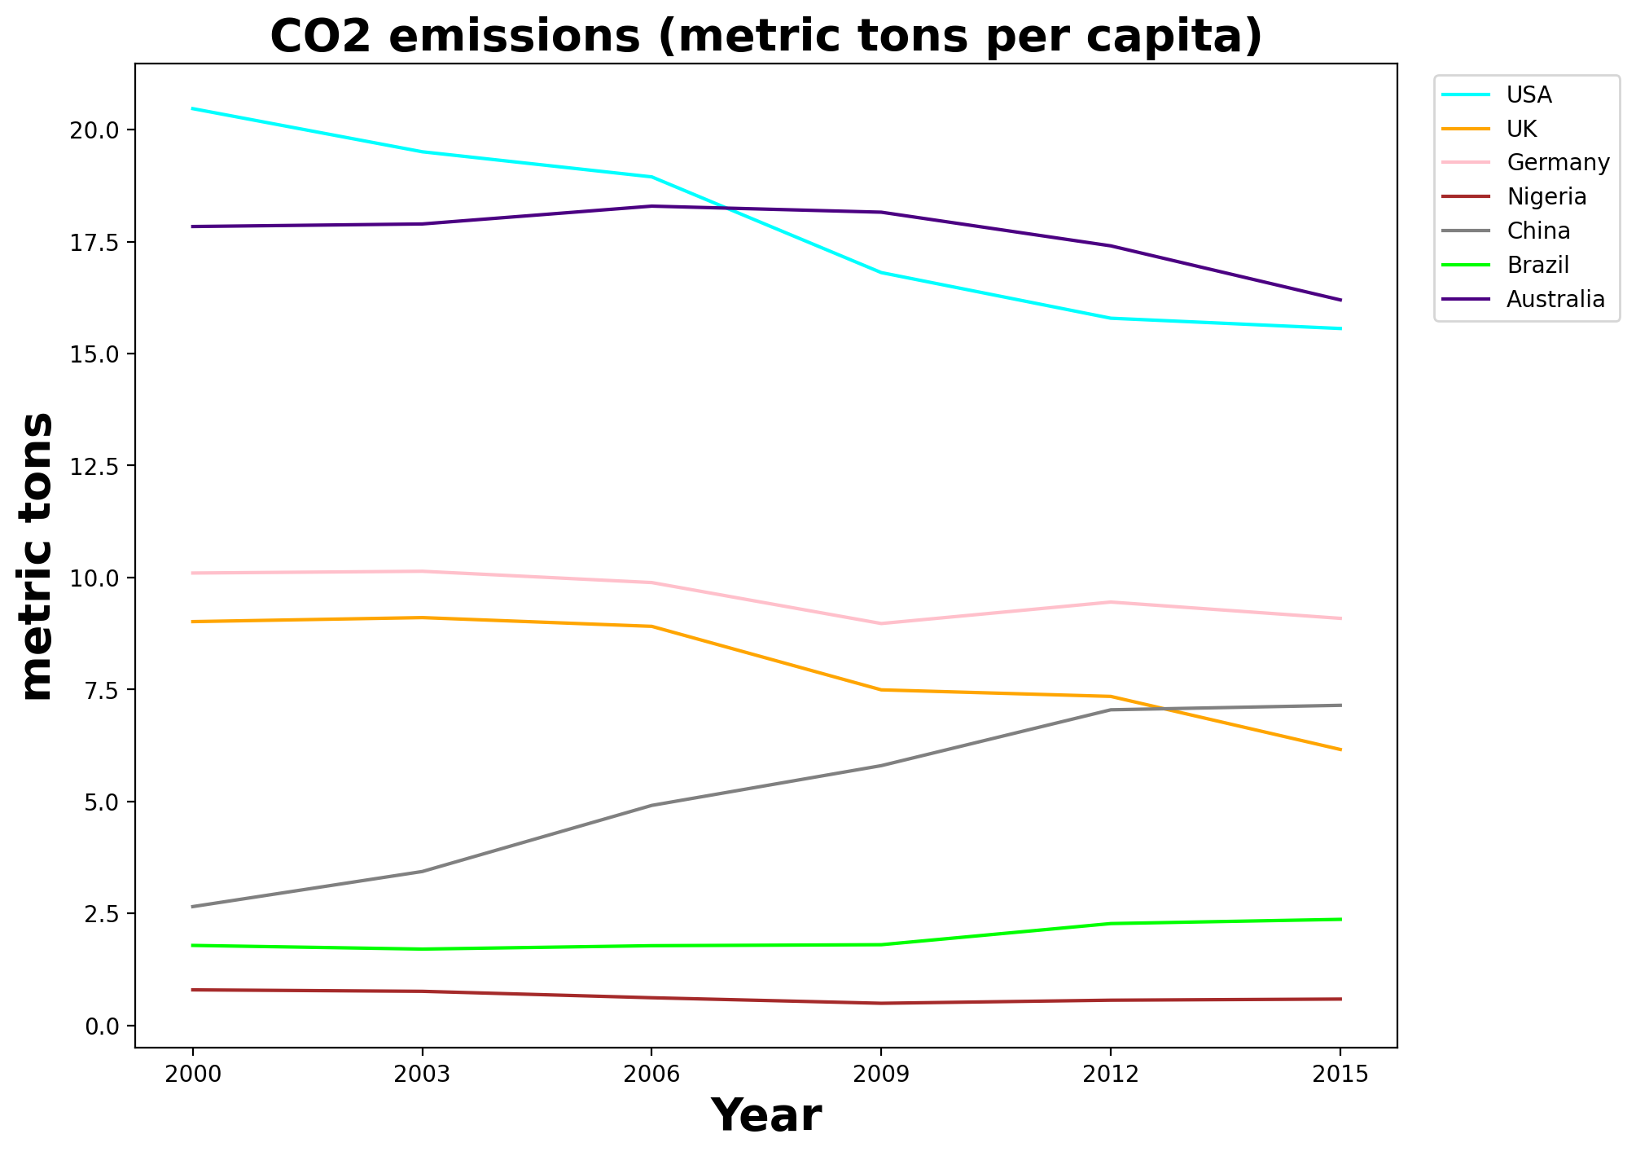

The narrative of CO2 emissions reveals a changing landscape. The USA, once the leader in per capita emissions, is now on a declining trajectory, signaling a positive shift in environmental responsibility. Meanwhile, China has consistently increased its per capita emissions, surpassing the UK. This reshuffling emphasizes the dynamic nature of global emissions, urging continuous efforts for environmental sustainability and climate change mitigation.

**Correlations Between Indicators for China**

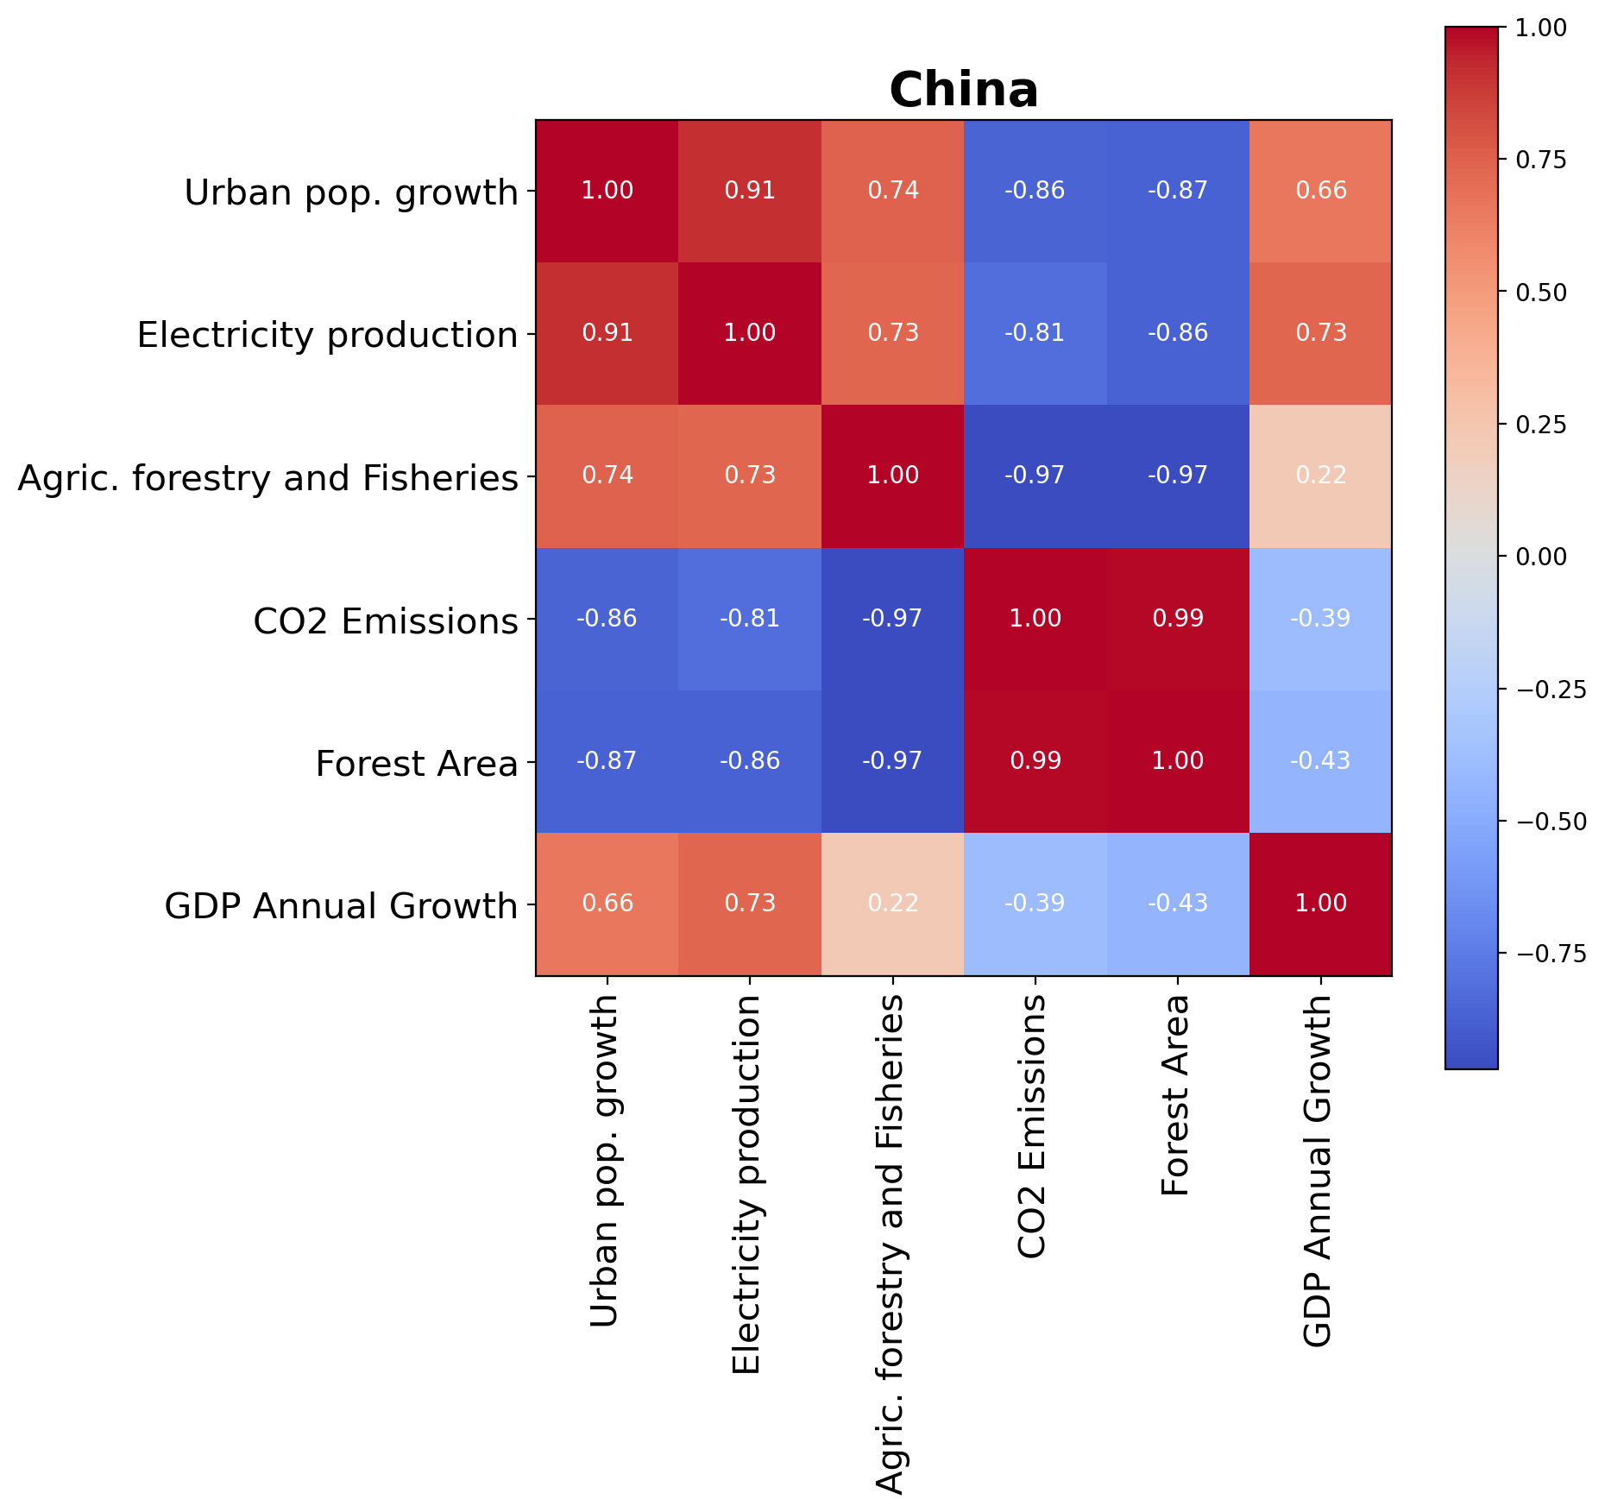

The correlation matrix for China's key indicators reveals interesting relationships. Urban population growth and electricity production exhibit a strong positive correlation of approximately 0.91, highlighting the simultaneous increase in urbanization and energy demand. Agriculture, forestry, and fisheries activities also show a positive correlation with urbanization and electricity production, suggesting a potential interconnectedness between these sectors. On the contrary, CO2 emissions display negative correlations with urban population growth, electricity production, and forest area, indicating efforts or policies that might contribute to environmental sustainability. The strong negative correlation between CO2 emissions and forest area underscores the importance of forest conservation in mitigating carbon emissions. Additionally, GDP annual growth is positively correlated with urbanization and electricity production, suggesting a link between economic development and increased urbanization and energy consumption.